**Objectives:**

* Define and understand the software development lifecycle in the context of the 3D TicTacToe programming project (Module B.5).
* Apply the lifecycle to anticipate and plan future activities that will be required to bring the 3D TicTacToe programming project to conclusion.

**Level 1: Defining The Software Development Lifecycle Phases**

The software development lifecycle involves the following distinct phases.

1. problem definition
2. analysis & design
3. writing code
4. testing
5. implementation & delivery
6. maintenance

For each of the above phases:

1. Research the definition in the context of software development
2. Explain how it applies (or will apply) to the 3D TicTacToe project

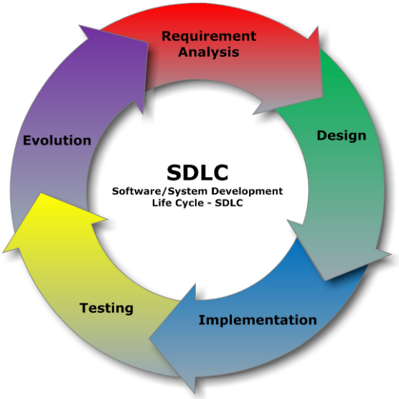

**Level 2: Understanding The Software Development Lifecycle Phases**

Explain how the problem definition phase could have been improved to produce a clearer specification that would result in a richer set of application features.

Consider the use of the following techniques: dialogue, questionnaires, surveys, and research

As a team, develop a tool / technique that will help to improve your 3D TicTacToe specification.

Think about what you did regarding analysis and design for the 3D TicTacToe project.

What was good about the process you followed?

What was bad about the process and what could be done to improve the process?

Think about what will be required for testing your 3D TicTacToe project code.

List some major things that you will have to test.

Research about what a software test plan looks like

Create a test plan for your 3D TicTacToe project code

For the delivery phase, think about what will be required to host a small 3D TicTacToe tournament for the Grade 11 Students.

How will the tournament be organized?

How will they load and run your TicTacToe application?

How will you deal with problems and bug reports?

**Level 3: Applying The Software Development Lifecycle Phases**

t.b.d

**Curriculum Notes**

B4.1 describe the phases (i.e., problem definition,

analysis, design, writing code, testing, implementation,

maintenance), milestones (e.g., date

of completion of program specification), and products

(e.g., specification, flow chart, program,

documentation, bug reports) of a software development

life cycle;

B4.3 use project management tools (e.g., Gantt

chart, critical path diagram, PERT chart) to show

tasks and milestones in a teacher-led project;

B4.6 communicate information about the status

of a project (e.g., milestones, work completed,

work outstanding) effectively in writing

throughout the project.

Grade